Jenkins Overview:

Once you login to Jenkins the first screen you will see is welcome screen. Since it is the first time you will see this screen. If you have created any jobs, you will those jobs list here.

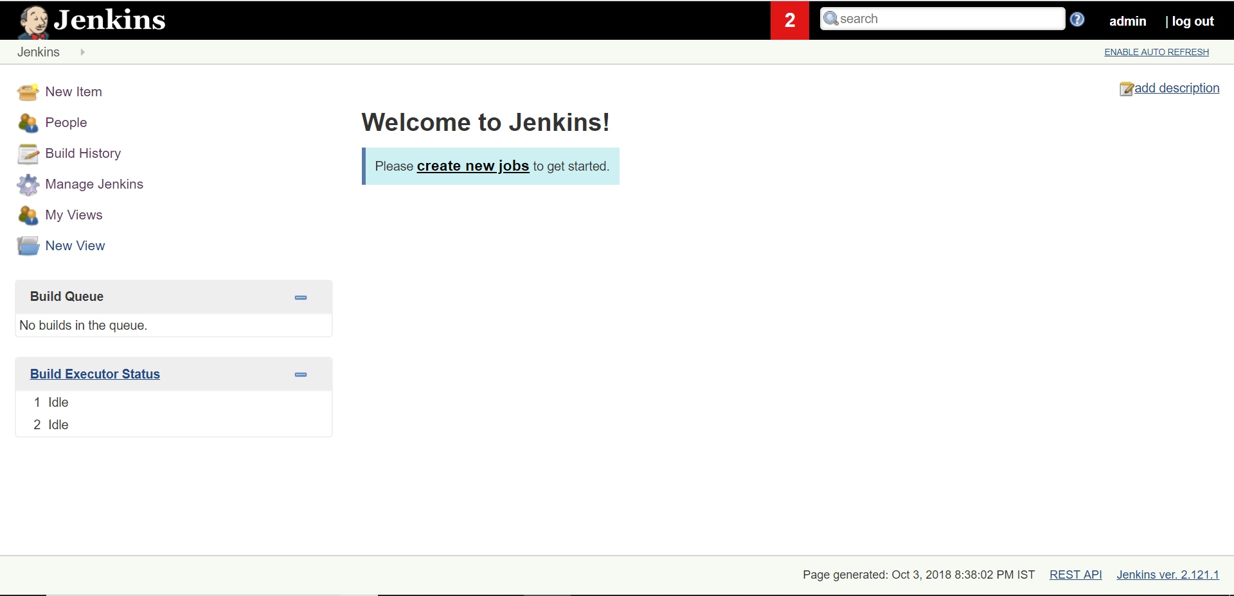

On the lefthand side you will see a menu.

New Item – You can create a new job here.

People – You can see all the users here.

Build Hisotry – It shows the jobs you have run.

Manage Jenkins – You can configure Jenkins here.

My Views – Here you can see the views you have created.

New View – You can create a new view here.

Build Queue – If multiple jobs are executing at a time, it shows all the jobs that are in queue to run.

Build Executor Status – It shows the jobs that are executing.

Lets have a look at the Manage Jenkins Section.

Manage Jenkins:

Once you click on Manage Jenkins you will see different options and the ones that we are interested are

* Configure System
* Global Tool Configuration
* Manage Plugins

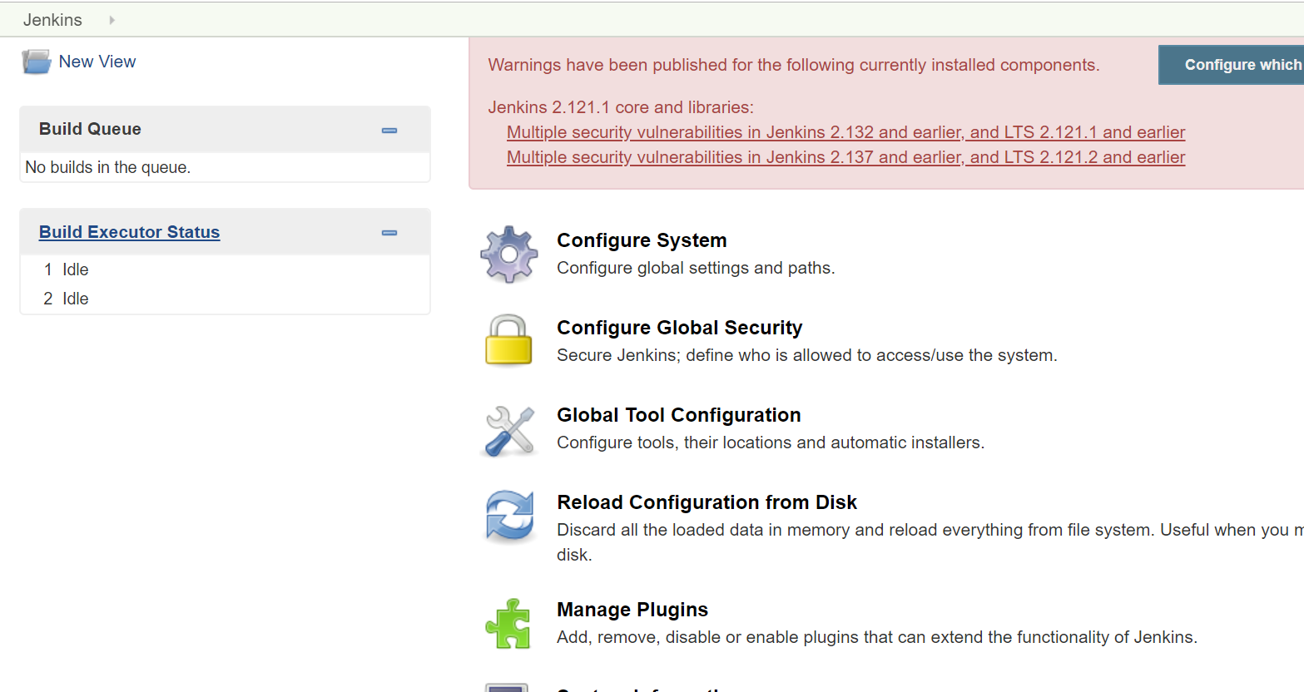

Configure System:

Here you can configure the global settings and paths. Once you open this the main setting we are interested in is System Admin’s mail. Jenkin’s URL shows the URL we are uing to access Jenkins.

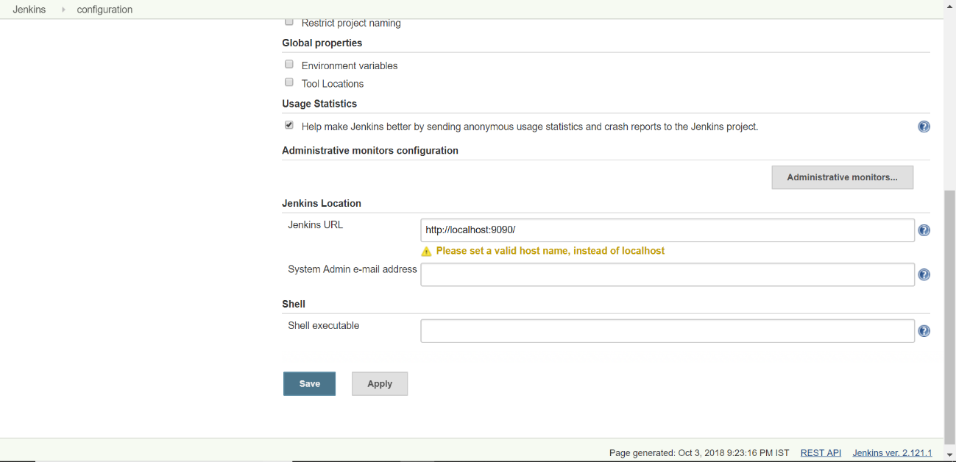

Next one is Global Tool Configuration:

Here we have to add the paths for JDK and MAVEN.

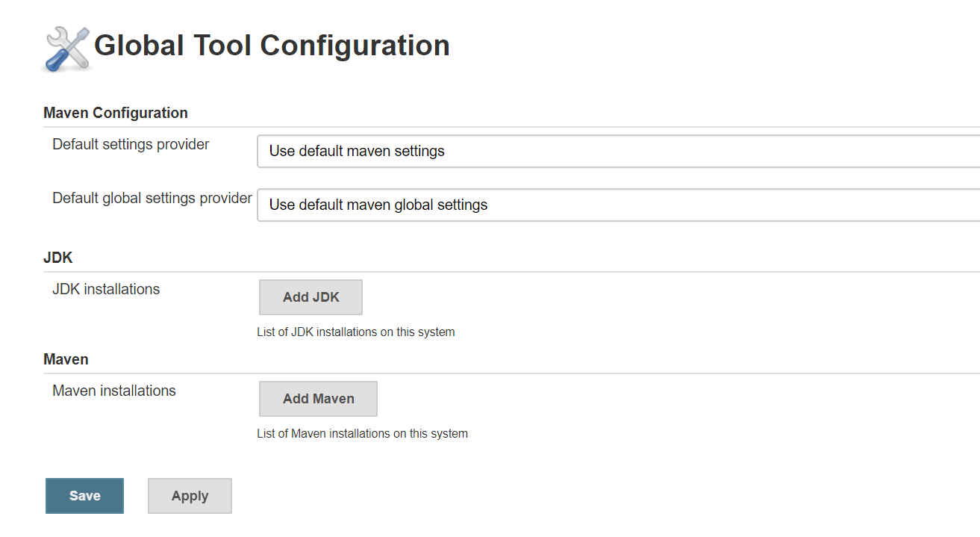

Next one is is Manage Plugins:

Here we can search for plugins and install them. The main plugins that we use are

1. TestNG Results
2. Test Results Analyzer

